Encoding–Decoding Constellations II: Sculpture

Piece:
i couldn’t find myself (in your cosmic presence), 2025

Materials:
Engraved plywood, acrylic paint, and light

Dimensions:
100 × 100 cm

Description:
This sculptural installation applies the encoding–decoding framework introduced in Project 1. A one-meter-square backing panel is engraved with a classical constellation pattern, forming a regular textured field. Above it, clusters of raised gold rosettes spread across the surface in a wild and freeform arrangement.
The piece began as an image of a rigid, lifeless system cracked open and shadowed by a vivid presence. During the making process, however, that relationship shifted: the rosettes came to resemble flowers blooming from fractures in the surface.
Suspended lighting further animates the work. As the light source moves, shifting shadows cause the image to expand and contract, creating a secondary drawing in light that extends the work’s interplay of structure, presence, movement, and continual remaking.
Shadowed and fragmented,
yet widening—
a field of rosettes blooms,
a nod to kintsugi.

Associated Media:

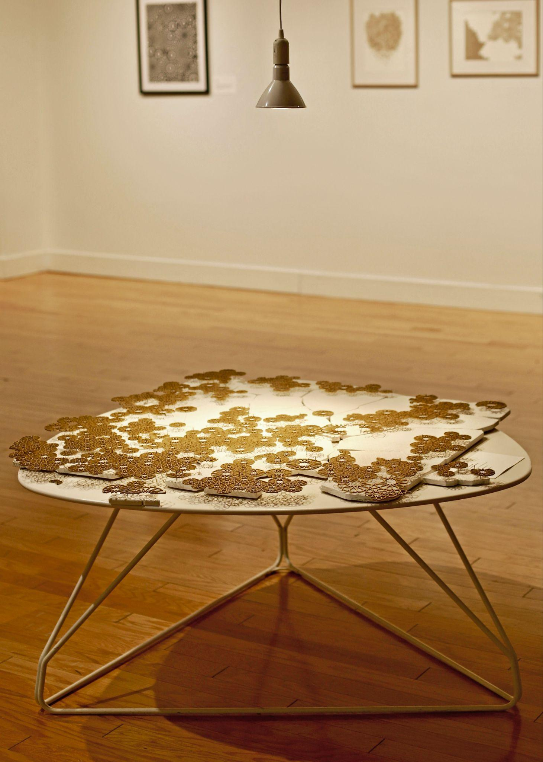
Media 1: i couldn’t find myself (in your cosmic presence).

Media 2: Animated shadows. See video.

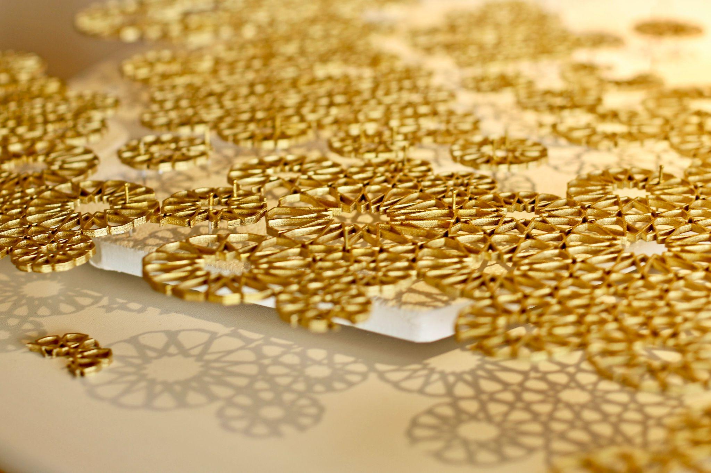
Media 3: Close up, side view.

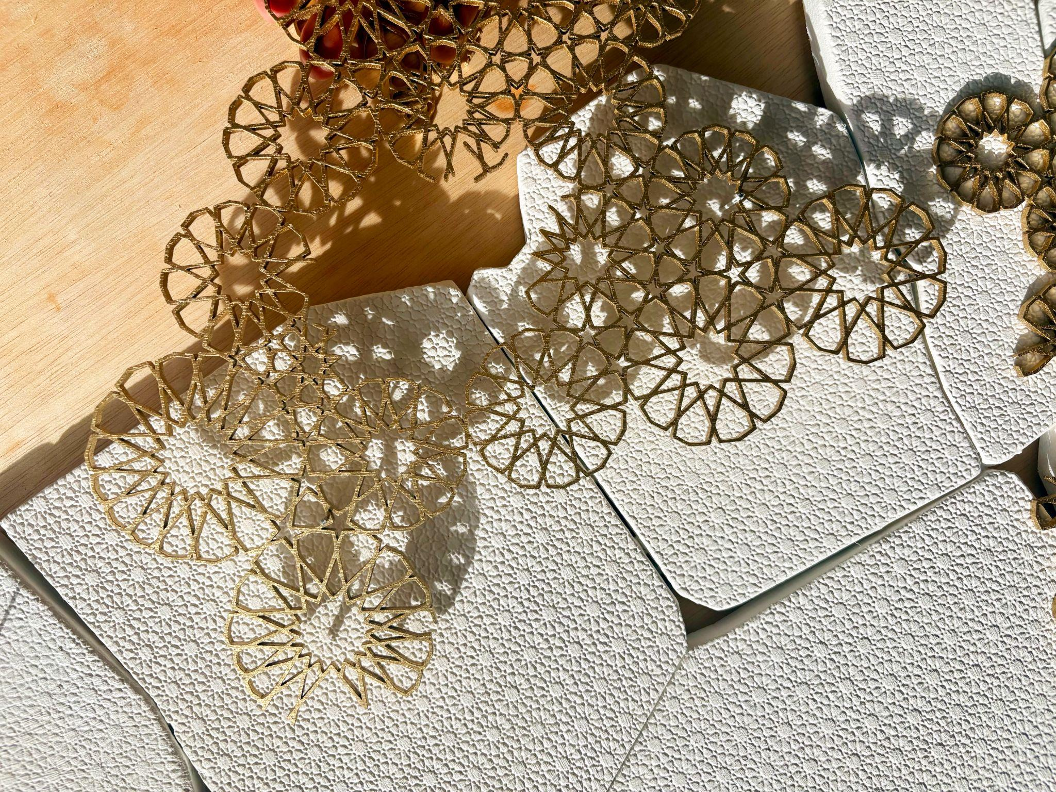
Media 4: Close up, top view.

